**Project Design Phase-II**

**Data Flow Diagram & User Stories**

|  |  |
| --- | --- |
| Date | 03 October 2022 |
| Team ID | PNT2022TMID35484 |
| Project Name | Project- Global Sales Data Analytics |
| Maximum Marks | 4 Marks |

**Data Flow Diagrams:**

A Data Flow Diagram (DFD) is a traditional visual representation of the information flows within a system. A neat and clear DFD can depict the right amount of the system requirement graphically. It shows how data enters and leaves the system, what changes the information, and where data is stored.

DFD Level-0 (Industry Standard)

**Example:** [**(Simplified)**](https://developer.ibm.com/patterns/visualize-unstructured-text/)

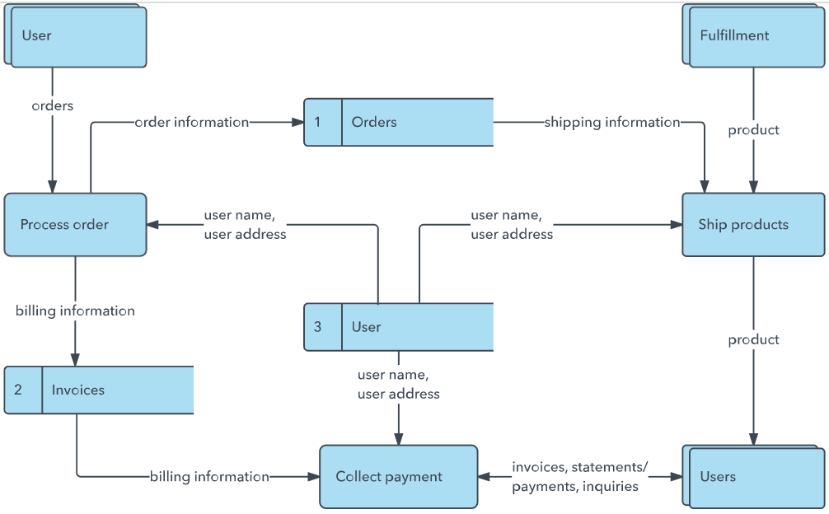

**](https://developer.ibm.com/patterns/visualize-unstructured-text/)**

**User Stories**

Use the below template to list all the user stories for the product.

| **User Type** | **Functional Requirement (Epic)** | **User Story Number** | **User Story / Task** | **Acceptance criteria** | **Priority** | **Release** |
| --- | --- | --- | --- | --- | --- | --- |
| Customer (Mobile user) | Registration | USN-1 | As a user, I can register for the application by entering my email, password, and confirming my password. | I can access my account / dashboard | High | Sprint-1 |
|  |  | USN-2 | As a user, I will receive confirmation email once I have registered for the application | I can receive confirmation email & click confirm | High | Sprint-1 |
|  |  | USN-3 | As a user, I can register for the application through Facebook | I can register & access the dashboard with Facebook Login | Low | Sprint-2 |
|  |  | USN-4 | As a user, I can register for the application through Gmail | I can receive notifications and access through email | Medium | Sprint-1 |
|  | Login | USN-5 | As a user, I can log into the application by entering email & password | I can access my account directly | High | Sprint-1 |
|  | Dashboard | USN-6 | As a user I can login and explore the interface | I was able to gather insights about the product | High | Sprint- 2 |
| Customer (Web user) | Registration | USN-7 | As a user, I can register for the application by entering my email, password, and confirming my password. | I can access my account / dashboard | High | Sprint-1 |
|  | Login | USN-8 | As a user, I can log into the application by entering email & password | I can access my account directly | High | Sprint-1 |
|  | Dashboard | USN-9 | As a user I can login and explore the interface | I was able to gather insights about the product | High | Sprint- 2 |
| Customer Care Executive | Query solving page | USN-10 | As a Customer Care Executive I am provided with a contact, solutions for different queries and a platform | The customers were able to easily reach out to get their queries solved and the executive was able to easily respond to the queries | High | Sprint- 3 |
| Administrator | Overall platform functionality | USN-11 | As an administrator I look for whether all the work in different domains are being carried well | The working of the store platform was smooth and minimum hinderances were encountered | High | Sprint-4 |